**Introduction to Micro Services**

**Notes:-**

**1-to run developer tools on vs 2019 on docker-compose >**

**Right click > open terminal window**

**2-execute the following command to generate all images and containers as below**

**docker-compose -f docker-compose.yml -f docker-compose.override.yml up -d**

**(async microservices communitcation)**

**to login on rabbit MQ go to the link 15672 and then type**

**guest**

**guest**

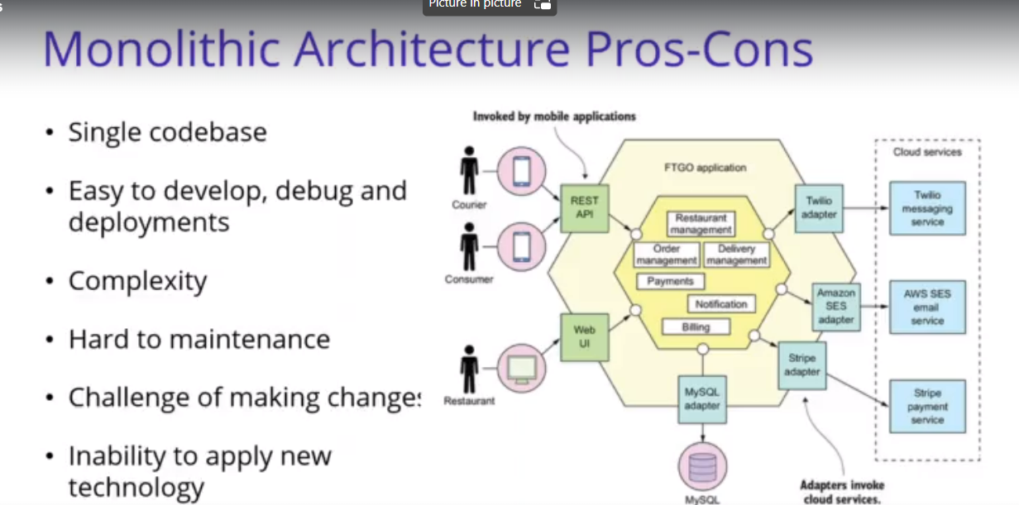

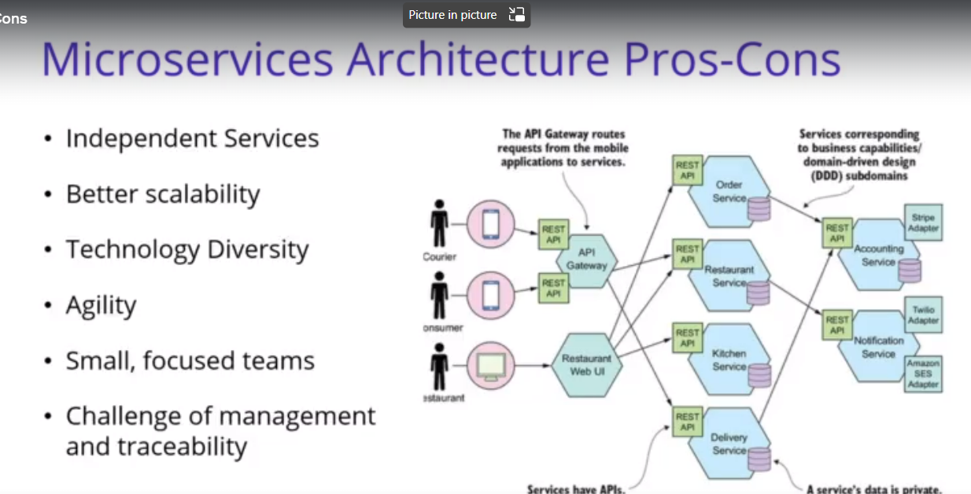

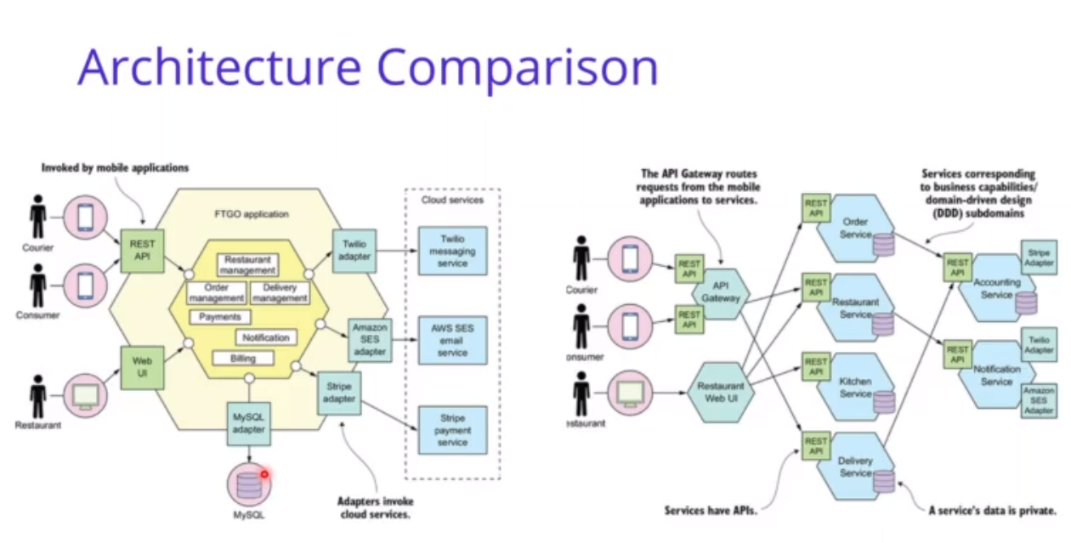

**Motholonic is single code base application that hold all parts while the micro services is group of small services that each one responsible of its database unlike the mothlonic that use the same database on all parts**

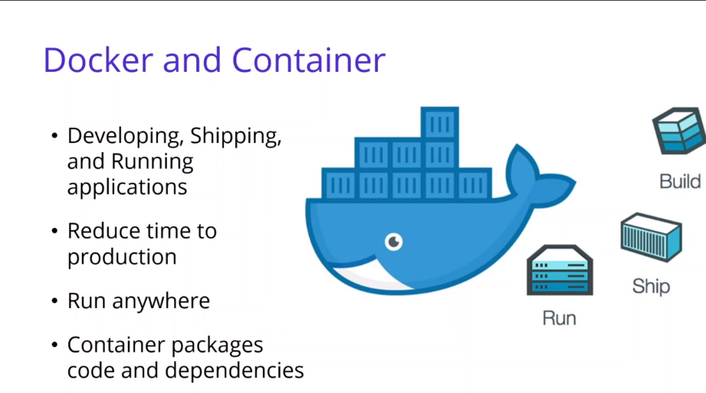

**Container is lightweight executable application that hold on the DOCKER environment**